**CONCEPTS OF ETHICAL HACKING LAB**

**WEEK – 8**

**Session Hijacking by cookie extraction using burp suite tool**

Demonstrating session hijacking by extracting cookie using the burp suite tool.

**Requirements:**

1. Burp suite.
2. Dvwa.

**Procedure:**

1. Download dvwa and configure it.
2. Open kali linux or download and install burp suite for windows.
3. Open burp suite and configure proxy server in firefox to intercept the request.
4. To configure proxy, go through the link <https://null-byte.wonderhowto.com/how-to/use-burp-foxyproxy-easily-switch-between-proxy-settings-0196630/>
5. Now when everything is configured turn on intercept in the burpsuite.
6. 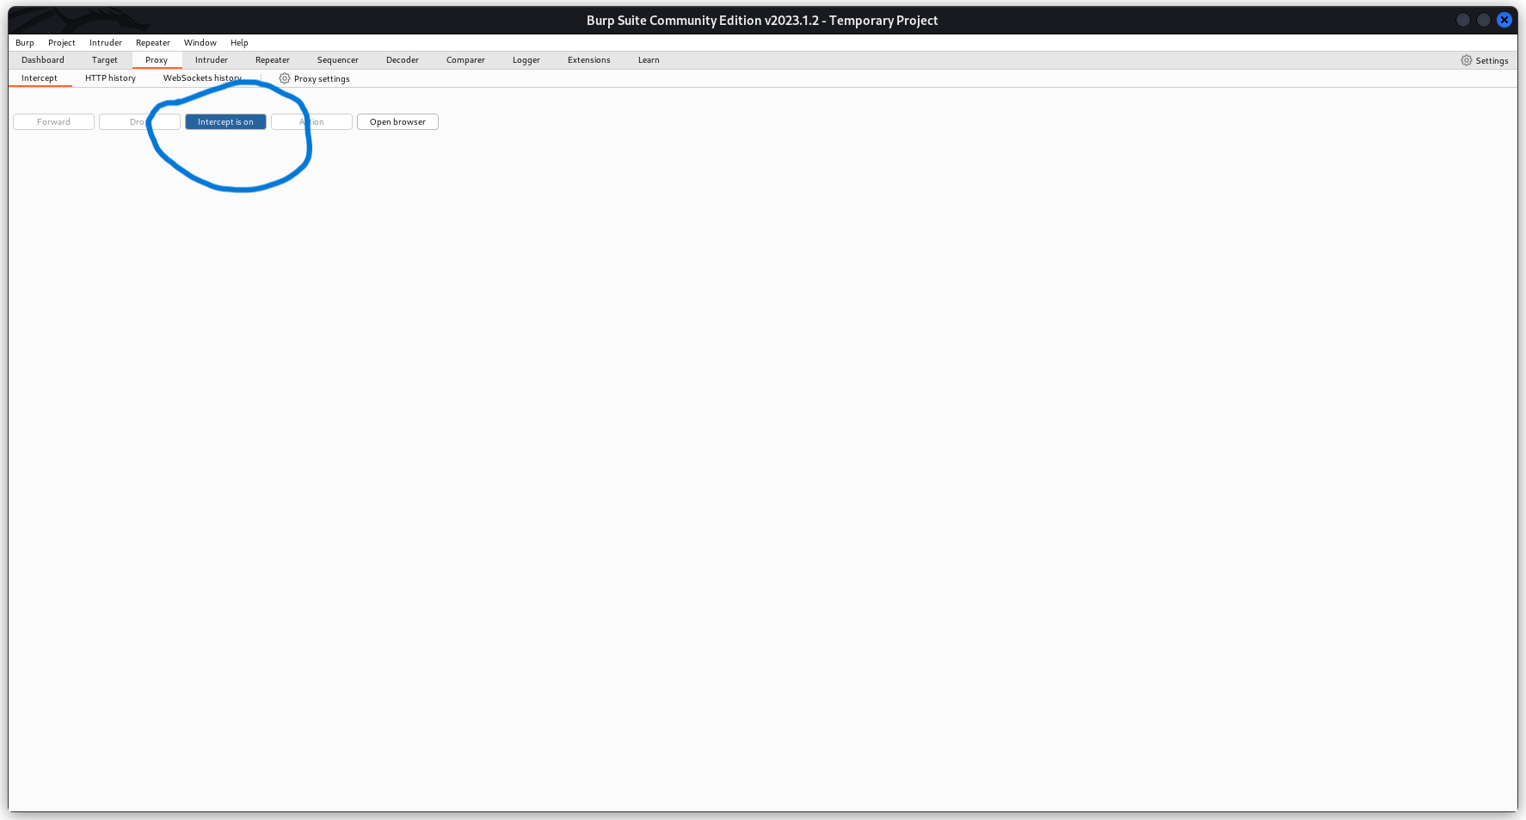
7. log into the dvwa page and intercept the request, right click on it and send it to repeater.
8. Graphical user interface

   Description automatically generated
9. Now this request contains a “PHPSESSIONID” which is the cookie.
10. Now even if you logout from the webpage just go to repeater tab and send the request and there will be a response.
11. Graphical user interface, text, application

    Description automatically generated
12. Right click on it, copy the url and open it in a browser.
13. Without any credentials, there will be direct login.